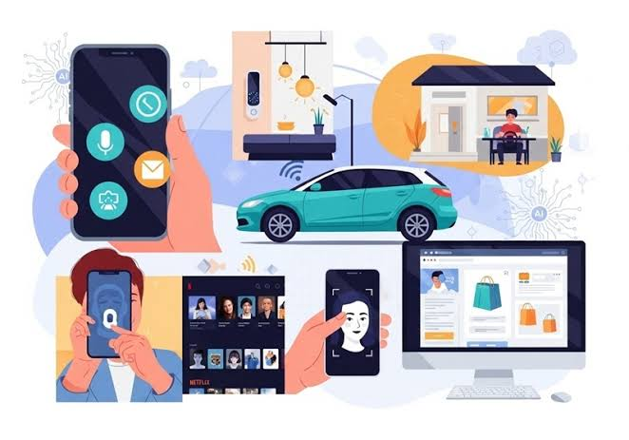
Meta Description:
Discover how Artificial Intelligence (AI) and Machine Learning (ML) shape your everyday life. Learn how Netflix, Spotify, Google Maps, Face Unlock, Google Translate, chatbots, and smart assistants use AI to make daily decisions easier.
AI in Your Pocket:
How Artificial Intelligence and
Machine Learning Influence
Everyday Decisions
By Swetha on July 13 at 12:03 am IST

Ever opened Netflix and wondered how it somehow knows exactly what you want to binge next? Or played Spotify only to find a playlist that perfectly matches your mood? Maybe you've used Google Maps to dodge traffic without thinking twice.
It feels like magic. But it isn't.
Artificial Intelligence (AI) and Machine Learning (ML) are already part of your everyday life. From recommending your next Netflix binge to helping you avoid traffic on Google Maps, AI quietly powers many of the apps you use every day.Whether you're unlocking your phone with your face, asking a smart assistant for the weather, or discovering a new favorite song on Spotify, chances are AI is working behind the scenes.
In this article, we'll explore how Artificial Intelligence and Machine Learning influence everyday decisions, making life faster, smarter, and more personalized.
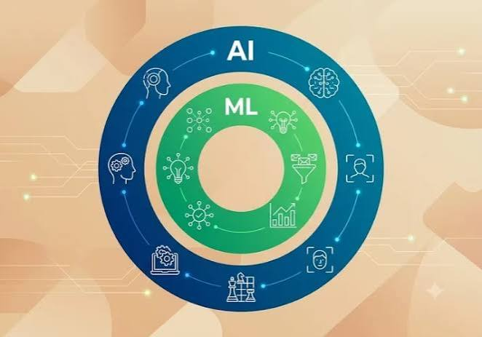
What Are Artificial Intelligence and Machine Learning?
Before diving into real-life examples, let's clear up a common misconception.
Artificial Intelligence (AI) is the ability of computers to perform tasks that usually require human intelligence, such as recognizing speech, understanding language, solving problems, or making decisions.
Machine Learning (ML) is a branch of AI that allows computers to learn from data and improve over time without being manually programmed for every situation.
Simply put:
- AI is the smart system.
- Machine Learning is how that system gets smarter.
Together, they power many of the digital experiences we rely on every day.

1. Netflix Recommendations: AI Knows Your Next Binge
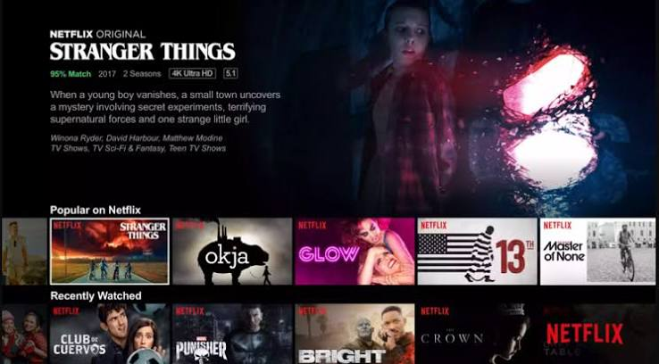
Ever opened Netflix and immediately found something you actually wanted to watch?
That's no coincidence.
Netflix uses Artificial Intelligence and Machine Learning to analyze your viewing habits, including:
- Movies and shows you watch
- Genres you enjoy
- Watch time
- Content you finish or stop watching
- Ratings and interactions
Based on this data, AI predicts what you're most likely to enjoy next.
Why it matters: Less endless scrolling and more personalized entertainment.

2. Spotify Playlists: Your Personal Music Expert
Have you ever wondered how Spotify's Discover Weekly always seems to match your vibe?
Spotify uses Machine Learning to analyse your listening habits, such as the artists you follow, songs you replay, tracks you skip, and playlists you create. It also compares your preferences with listeners who enjoy similar music.
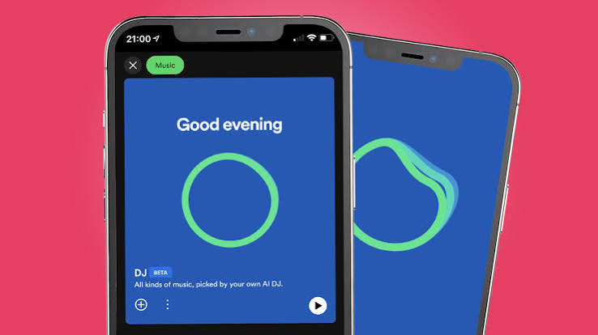
Using this data, Spotify creates personalized playlists that introduce you to new songs while still matching your taste. The more you listen, the better the recommendations become, making it feel like you have your own personal DJ.

3. Google Maps: Smarter Routes in Real Time
Google Maps does much more than provide directions.
Using Artificial Intelligence, it analyses real-time traffic, accidents, road closures, and travel patterns from millions of users. Machine Learning then predicts where congestion is likely to happen and recommends the fastest available route.

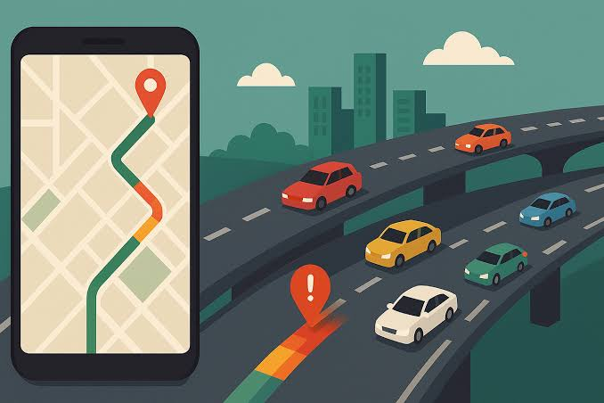
Whether you're heading to work or traveling somewhere new, AI helps reduce travel time and avoid unnecessary delays. It's a simple feature that saves time and makes daily commuting much less stressful.

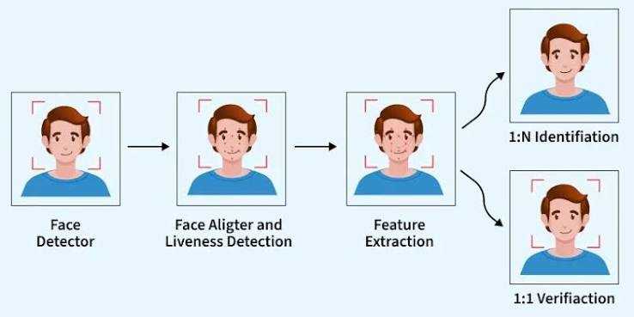
4. Face Unlock: Security Powered by AI

Unlocking your phone has never been easier.
Face Unlock uses AI-powered facial recognition to identify unique features such as your facial shape, eye spacing, and facial contours. Modern systems can even recognize you in different lighting conditions or while wearing glasses.
This technology provides a faster and more secure alternative to traditional passwords or PINs. In just a second, AI confirms your identity and unlocks your device, giving you both convenience and improved security.

5. Google Translate: Breaking Language Barriers
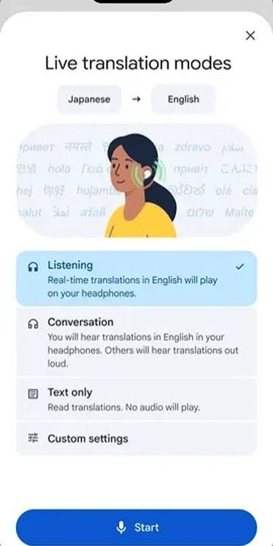
Communicating in another language is easier than ever thanks to Artificial Intelligence.
Google Translate uses Machine Learning to understand the context and meaning of entire sentences instead of translating each word individually. This results in translations that sound more natural and accurate.
Whether you're traveling, studying, or reading content from another country, AI helps bridge language barriers and makes communication faster, smoother, and more accessible for millions of people every day.

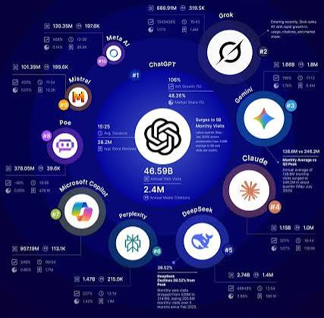
6. AI Chatbots: Customer Support Anytime
Have you ever contacted customer support late at night and received an instant reply?
Chances are, you were chatting with an AI chatbot.
These virtual assistants can answer common questions, track orders, process simple requests, and guide users through basic problems within seconds.
Because they're available 24/7, businesses can provide quick support without making customers wait. When a request becomes more complex, the chatbot can hand the conversation over to a human support agent for further assistance.
Final Thoughts
Artificial Intelligence and Machine Learning are no longer technologies of the future they're already shaping the choices we make every day.
From Netflix recommendations and Spotify playlists to Google Maps, Face Unlock, Google Translate, chatbots, and smart assistants, AI has quietly become part of our daily routine.
The next time your phone recommends the perfect movie, finds the fastest route home, or understands exactly what you mean, remember:
It's not reading your mind.
It's learning from your habits to make everyday life a little smarter.
AI isn't just in the future. It's already in your pocket.

